ATMIYA UNIVERSITY
RAJKOT


A
Report On
Smart Wardrobe & Outfit Planner
Under subject of
MINI PROJECT
B.TECH, Semester – VII
(Computer Engineering)

Submitted by:
1. | Parmar Bhuresh M. | 230002061

Mr. Birju Tank
(Faculty Guide)

Dr. Tosal M. Bhalodia
(Head of the Department)

Academic Year
(2026-27)
CANDIDATE’S DECLARATION

We hereby declare that the work presented in this project entitled “Smart Wardrobe & Outfit Planner” submitted towards completion of project in 7th Semester of B. Tech. (Computer Engineering) is an authentic record of our original work carried out under the guidance of “Mr. Birju Tank”.

We have not submitted the matter embodied in this project for the award of any other degree.

Semester: 7th
Place: Rajkot

Signature:
Parmar Bhuresh M. (230002061)

ATMIYA UNIVERSITY
RAJKOT

CERTIFICATE

Date:

This is to certify that the “Smart Wardrobe & Outfit Planner” has been carried out by Bhuresh Parmar under my guidance in fulfillment of the subject Mini Project in COMPUTER ENGINEERING (7th Semester) of Atmiya University, Rajkot during the academic year 2026.

Mr. Birju Tank Dr. Tosal M. Bhalodia

(Project Guide) (Head of the Department)

ACKNOWLEDGEMENT

We have taken many efforts in this project. However, it would not have been possible without the kind support and help of many individuals and organizations. We would like to extend our sincere thanks to all of them.

We are highly indebted to Mr. Birju Tank for their guidance and constant supervision as well as for providing necessary information regarding the Project titled “Smart Wardrobe & Outfit Planner “ We would like to express our gratitude towards staff members of the Computer Engineering Department, Atmiya University for their kind co-operation and encouragement which helped us in completion of this project.

We even thank and appreciate our colleague in developing the project and people who have willingly helped us out with their abilities.

Parmar Bhuresh M. (230002061)

ABSTRACT
The Smart Wardrobe & Outfit Planner (Alcove) is a full-stack AI-driven web application designed to solve daily clothing decision fatigue and eliminate wardrobe underutilization. Built on the MERN stack (MongoDB, Express.js, React.js, Node.js) integrated with a Python deep learning computer vision microservice (PyTorch & OpenCV) and OpenWeatherMap REST APIs, the system allows users to digitize their apparel catalog via photo uploads. The deep learning model automatically classifies clothing categories ('tops', 'bottoms', 'outerwear', 'shoes', 'dresses', 'accessories') and detects HSV primary/secondary color attributes, supported by an interactive manual confirmation fallback UX (< 60% confidence threshold). An intelligent recommendation engine combines ambient temperature, weather forecasts, occasion tags, and user preferences to assemble complete outfit combinations, accompanied by natural-language styling rationale generated via Google Gemini LLM API. Additional system features include a wear-history tracking calendar, wardrobe gap analysis flagging underused apparel categories, a travel trip packing list generator, and guest-accessible outfit sharing links. The application enforces strict security using bcrypt password hashing (10 salt rounds) and stateless JWT token authorization.

INDEX

Sr. No. | TITLES | Page No.
 | Acknowledgement | I
 | Abstract | II
 | List of Figures | III
 | List of Tables | IV
1. | CHAPTER 1: INTRODUCTION | 1
 | 1.1 Purpose | 1
 | 1.2 Scope | 2
 | 1.3 Technology and tools | 3
2. | CHAPTER 2: PROJECT MANAGEMENT | 5
 | 2.1 Project Planning | 5
 | 2.2 Project Scheduling | 6
 | 2.3 Risk Management | 7
3. | CHAPTER 3: SYSTEM REQUIREMENTS STUDY | 9
 | 3.1 Hardware and Software Requirements | 9
 | 3.2 Constraints | 11
4. | CHAPTER 4: SYSTEM ANALYSIS | 13
 | 4.1 Study of Current System | 13
 | 4.2 Problem and Weaknesses of Current System | 14
 | 4.3 Requirements of New System | 15
 | 4.4 Feasibility Study | 16
 | 4.5 Features Of New System | 17
5. | CHAPTER 5: SYSTEM DESIGN | 18
 | 5.1 Input / Output interface | 18
 | 5.2 Interface Design (UML Diagrams - Black & White) | 19
 | 5.3 Screen Designs (Web Screenshots - Color) | 27
6. | CHAPTER 6: CODE IMPLEMENTATION | 33
 | 6.1 Implementation Environment | 33
 | 6.2 Program / Module Specification | 34
 | 6.3 Coding Standards | 35
7. | CHAPTER 7: TESTING | 36
 | 7.1 Testing Strategy | 36
 | 7.2 Testing Method | 37
 | 7.3 Test Cases (Black & White Matrix) | 38
8. | CHAPTER 8: LIMITATIONS AND FUTURE ENHANCEMENT | 40
 | 8.1 Limitations | 40
 | 8.2 Future Enhancement | 41
9. | CHAPTER 9: CONCLUSION | 42
10. | CHAPTER 10: REFERENCES | 43

LIST OF FIGURES
Fig. 5.1 | System Architecture Diagram (Black & White) | 19
Fig. 5.2 | UML Class Diagram (Black & White) | 20
Fig. 5.3 | UML Use Case Diagram (Black & White) | 21
Fig. 5.4 | UML Activity Diagram — Image Upload & Tagging (Black & White) | 22
Fig. 5.5 | Data Flow Diagram DFD Level 0 (Black & White) | 23
Fig. 5.6 | UML State Diagram — Clothing Lifecycle (Black & White) | 24
Fig. 5.7 | Entity-Relationship (ER) Diagram (Black & White) | 25
Fig. 5.8 | UML Sequence Diagram — Outfit Generation (Black & White) | 26
Fig. 5.9 | Screen Design — User Authentication (Color) | 27
Fig. 5.10 | Screen Design — Dashboard Overview (Color) | 28
Fig. 5.11 | Screen Design — Digital Wardrobe Catalog (Color) | 29
Fig. 5.12 | Screen Design — AI Outfit Generator (Color) | 30
Fig. 5.13 | Screen Design — Wear History Calendar (Color) | 31
Fig. 5.14 | Screen Design — Wardrobe Gap Analysis (Color) | 32
Fig. 5.15 | Screen Design — Trip Packing List Generator (Color) | 32
Fig. 5.16 | Screen Design — Outfit Sharing Interface (Color) | 33

LIST OF TABLES
Table 2.1 | Project Development Milestones & Schedule | 6
Table 2.2 | Risk Identification and Mitigation Matrix | 8
Table 3.1 | Server-Side Hardware and Software Requirements | 10
Table 3.2 | Client-Side Hardware and Software Requirements | 11
Table 4.1 | Feasibility Evaluation Matrix | 16
Table 5.1 | Database Schemas & Data Model Attributes | 18
Table 7.1 | Black & White Test Cases Suite Matrix (TC-01 to TC-10) | 38

Sprint / Week | Milestone / Activity | Key Deliverables | Status
Week 1 - 2 | Requirement Analysis & System Architecture | SRS document, UML diagrams, MongoDB schema design | Completed
Week 3 - 4 | Backend & Database Implementation | Node/Express REST API routes, JWT Auth, Multer storage | Completed
Week 5 - 6 | AI Engine Development & Model Training | PyTorch CNN classifier, HSV color detector, Flask API | Completed
Week 7 | React Frontend & Feature Integration | React components, Glassmorphism UI, OpenWeather/Gemini API | Completed
Week 8 | Testing, Optimization & Report Preparation | Jest testing, model evaluation, final documentation & viva demo | Completed
Risk ID | Risk Description | Impact | Probability | Mitigation Strategy
R-1 | AI Classification Error | Medium | Medium | Interactive user confirmation fallback UX (< 60% confidence threshold)
R-2 | API Latency / Timeout | High | Low | Rule-based recommendation fallback matrix & 5-second HTTP timeout limit
R-3 | Data Breach / Unauthorized Access | High | Low | Bcrypt password hashing (10 rounds) and stateless JWT Bearer authorization
Hardware Component | Minimum Requirement | Recommended Specification
Processor (CPU) | Dual-Core 2.0 GHz (Intel i3 / AMD Ryzen 3) | Quad-Core 3.0 GHz+ (Intel i5/i7 or AMD Ryzen 5/7)
System Memory (RAM) | 4 GB DDR4 | 8 GB DDR4 or higher
Storage Space | 10 GB available SSD space | 25 GB High-Speed NVMe SSD
Network Interface | 100 Mbps Ethernet / Wi-Fi | 1 Gbps High-Speed Network Connection
Client Component | Minimum Requirement
Device Type | Desktop Computer, Laptop, Tablet, or Smartphone
Web Browser | Google Chrome 100+, Mozilla Firefox 100+, Microsoft Edge 100+, Safari 15+
Display Resolution | 1280 x 720 (Desktop) / 375 x 667 (Mobile viewport)
Network | Broadband Internet connection or Local Area Network (LAN)
Feasibility Dimension | Evaluation Summary | Status
Technical Feasibility | Leverages standard MERN stack, PyTorch, and REST APIs; fully feasible. | Feasible
Operational Feasibility | Intuitive glassmorphism UI requiring minimal user effort; high adoption feasibility. | Feasible
Economic Feasibility | Built using open-source tools and free-tier cloud resources; highly cost-effective. | Feasible
Schedule Feasibility | Planned milestones successfully executed within the 8-week academic window. | Feasible
Test ID | Module | Test Scenario | Input Payload | Expected Result | Status
TC-01 | Auth | User Registration | Valid name, email, password | HTTP 201 + JWT Token issued | PASS
TC-02 | Auth | Duplicate Email | Existing registered email | HTTP 400 'User already exists' | PASS
TC-03 | Auth | Invalid Login | Incorrect password | HTTP 401 'Invalid credentials' | PASS
TC-04 | Wardrobe | Protected Route | GET /api/wardrobe (no token) | HTTP 401 'Authentication required' | PASS
TC-05 | Wardrobe | Image Upload | Valid JPEG clothing image | HTTP 200 + AI predicted tags | PASS
TC-06 | Wardrobe | Status Update | PUT status='laundry' | Item status updated to 'laundry' | PASS
TC-07 | AI Engine | Service Disconnection | POST image (Flask offline) | HTTP 503 + aiEngineDown=true | PASS
TC-08 | Outfit | Outfit Generation | Occasion='casual', temp=22°C | Valid top + bottom pair returned | PASS
TC-09 | Calendar | Log Wear History | Outfit ID + Date payload | Wear log created + wornCount++ | PASS
TC-10 | Trip | Generate Packing | Destination='Mumbai', 3 days | Minimal packing checklist output | PASS
Sprint / Week | Milestone / Activity | Key Deliverables | Status
Week 1 - 2 | Requirement Analysis & System Architecture | SRS document, UML diagrams, MongoDB schema design | Completed
Week 3 - 4 | Backend & Database Implementation | Node/Express REST API routes, JWT Auth, Multer storage | Completed
Week 5 - 6 | AI Engine Development & Model Training | PyTorch CNN classifier, HSV color detector, Flask API | Completed
Week 7 | React Frontend & Feature Integration | React components, Glassmorphism UI, OpenWeather/Gemini API | Completed
Week 8 | Testing, Optimization & Report Preparation | Jest testing, model evaluation, final documentation & viva demo | Completed
Risk ID | Risk Description | Impact | Probability | Mitigation Strategy
R-1 | AI Classification Error | Medium | Medium | Interactive user confirmation fallback UX (< 60% confidence threshold)
R-2 | API Latency / Timeout | High | Low | Rule-based recommendation fallback matrix & 5-second HTTP timeout limit
R-3 | Data Breach / Unauthorized Access | High | Low | Bcrypt password hashing (10 rounds) and stateless JWT Bearer authorization
Hardware Component | Minimum Requirement | Recommended Specification
Processor (CPU) | Dual-Core 2.0 GHz (Intel i3 / AMD Ryzen 3) | Quad-Core 3.0 GHz+ (Intel i5/i7 or AMD Ryzen 5/7)
System Memory (RAM) | 4 GB DDR4 | 8 GB DDR4 or higher
Storage Space | 10 GB available SSD space | 25 GB High-Speed NVMe SSD
Network Interface | 100 Mbps Ethernet / Wi-Fi | 1 Gbps High-Speed Network Connection
Client Component | Minimum Requirement
Device Type | Desktop Computer, Laptop, Tablet, or Smartphone
Web Browser | Google Chrome 100+, Mozilla Firefox 100+, Microsoft Edge 100+, Safari 15+
Display Resolution | 1280 x 720 (Desktop) / 375 x 667 (Mobile viewport)
Network | Broadband Internet connection or Local Area Network (LAN)
Feasibility Dimension | Evaluation Summary | Status
Technical Feasibility | Leverages standard MERN stack, PyTorch, and REST APIs; fully feasible. | Feasible
Operational Feasibility | Intuitive glassmorphism UI requiring minimal user effort; high adoption feasibility. | Feasible
Economic Feasibility | Built using open-source tools and free-tier cloud resources; highly cost-effective. | Feasible
Schedule Feasibility | Planned milestones successfully executed within the 8-week academic window. | Feasible
Test ID | Module | Test Scenario | Input Payload | Expected Result | Status
TC-01 | Auth | User Registration | Valid name, email, password | HTTP 201 + JWT Token issued | PASS
TC-02 | Auth | Duplicate Email | Existing registered email | HTTP 400 'User already exists' | PASS
TC-03 | Auth | Invalid Login | Incorrect password | HTTP 401 'Invalid credentials' | PASS
TC-04 | Wardrobe | Protected Route | GET /api/wardrobe (no token) | HTTP 401 'Authentication required' | PASS
TC-05 | Wardrobe | Image Upload | Valid JPEG clothing image | HTTP 200 + AI predicted tags | PASS
TC-06 | Wardrobe | Status Update | PUT status='laundry' | Item status updated to 'laundry' | PASS
TC-07 | AI Engine | Service Disconnection | POST image (Flask offline) | HTTP 503 + aiEngineDown=true | PASS
TC-08 | Outfit | Outfit Generation | Occasion='casual', temp=22°C | Valid top + bottom pair returned | PASS
TC-09 | Calendar | Log Wear History | Outfit ID + Date payload | Wear log created + wornCount++ | PASS
TC-10 | Trip | Generate Packing | Destination='Mumbai', 3 days | Minimal packing checklist output | PASS
CHAPTER – 1
INTRODUCTION
1.1 Purpose
The primary purpose of the Smart Wardrobe & Outfit Planner (Alcove) is to eliminate daily clothing decision fatigue and maximize the utilization of owned wardrobe items through intelligent digital cataloging and AI-assisted outfit recommendations. Despite owning numerous garments, individuals frequently experience choice overload every morning, leading to repetitive use of a tiny fraction of their wardrobe while remaining items sit neglected. Existing solutions either require laborious manual data entry or lack context-aware recommendation capabilities. Alcove bridges this gap by combining computer vision photo-tagging, live weather metrics, and generative AI natural-language reasoning into a seamless web platform.
1.2 Scope
The project scope encompasses an end-to-end full-stack web application supporting:
• Photo-based Wardrobe Digitization: Automatic detection of apparel category ('tops', 'bottoms', 'outerwear', 'shoes', 'dresses', 'accessories') and primary/secondary HSV colors via PyTorch deep learning microservices.
• Weather & Occasion Outfit Generation: Assembling complete, weather-appropriate outfits matching selected occasions (casual, formal, gym, party) using OpenWeatherMap live forecasts and Gemini LLM styling rationale.
• Wear History & Calendar Tracking: Interactive calendar interface logging outfit wear dates and updating item wear frequency analytics.
• Wardrobe Gap Analysis: Identifying under-represented clothing categories and supplying natural-language purchase advice.
• Trip Packing List Generation: Creating minimal, weather-checked packing checklists for multi-day trips.
• Outfit Sharing: Generating guest-accessible shared outfit URLs for feedback.
1.3 Technology and Tools
The application is engineered using modern web, machine learning, and cloud technologies:
• Frontend Layer: React.js 18 (JSX), Vite 5, Tailwind CSS 3 (Glassmorphism design system), Lucide React Icons, Axios REST client.
• Backend Layer: Node.js, Express.js REST API server, Mongoose ODM, JSON Web Tokens (JWT), Bcrypt.js, Multer file uploader, Winston/Morgan logging.
• Database Layer: MongoDB (Atlas Cloud-hosted / Local instance) storing User, ClothingItem, Outfit, OutfitLog, Trip, and ClothingCorrection collections.
• AI & Computer Vision Microservice: Python 3.10, PyTorch, OpenCV, Pillow, Scikit-learn, Flask REST server.
• External APIs: OpenWeatherMap REST API (current/forecast weather) and Google Gemini LLM API (natural language reasoning).
CHAPTER – 2
PROJECT MANAGEMENT
2.1 Project Planning
The project was managed using an Agile development framework structured across four two-week sprints. Each sprint incorporated requirement definition, component design, implementation, and code review checkpoints.
2.2 Project Scheduling
Table 2.1 details the project development milestones and execution timeline across the 8-week schedule:
Sprint / Week | Milestone / Activity | Key Deliverables | Status
Week 1 - 2 | Requirement Analysis & System Architecture | SRS document, UML diagrams, MongoDB schema design | Completed
Week 3 - 4 | Backend & Database Implementation | Node/Express REST API routes, JWT Auth, Multer storage | Completed
Week 5 - 6 | AI Engine Development & Model Training | PyTorch CNN classifier, HSV color detector, Flask API | Completed
Week 7 | React Frontend & Feature Integration | React components, Glassmorphism UI, OpenWeather/Gemini API | Completed
Week 8 | Testing, Optimization & Report Preparation | Jest testing, model evaluation, final documentation & viva demo | Completed

2.3 Risk Management
Risk management involved identifying technical, operational, and architectural risks and establishing preventive strategies.
2.3.1 Risk Identification
• R-1 (Technical): AI classification inaccuracy due to poor photo lighting or cluttered backgrounds.
• R-2 (Technical): Latency or unresponsiveness in the external Generative AI or Weather APIs.
• R-3 (Security): Unauthorized access to personal clothing catalogs or unhashed password exposure.
2.3.2 Risk Analysis and Mitigation
Risk ID | Risk Description | Impact | Probability | Mitigation Strategy
R-1 | AI Classification Error | Medium | Medium | Interactive user confirmation fallback UX (< 60% confidence threshold)
R-2 | API Latency / Timeout | High | Low | Rule-based recommendation fallback matrix & 5-second HTTP timeout limit
R-3 | Data Breach / Unauthorized Access | High | Low | Bcrypt password hashing (10 rounds) and stateless JWT Bearer authorization

CHAPTER – 3
SYSTEM REQUIREMENTS STUDY
3.1 Hardware and Software Requirements
3.1.1 Server Side Hardware Requirement
Hardware Component | Minimum Requirement | Recommended Specification
Processor (CPU) | Dual-Core 2.0 GHz (Intel i3 / AMD Ryzen 3) | Quad-Core 3.0 GHz+ (Intel i5/i7 or AMD Ryzen 5/7)
System Memory (RAM) | 4 GB DDR4 | 8 GB DDR4 or higher
Storage Space | 10 GB available SSD space | 25 GB High-Speed NVMe SSD
Network Interface | 100 Mbps Ethernet / Wi-Fi | 1 Gbps High-Speed Network Connection

3.1.2 Software Requirement
Software environments required to run and maintain the project:
• Operating System: Windows 10/11 64-bit or Ubuntu Linux 20.04 LTS.
• Runtime Environments: Node.js v18.0+ (with npm v9+), Python v3.10+.
• Database Management System: MongoDB v6.0+ (Atlas cloud or local daemon).
• Development Tools: Visual Studio Code, Git, Postman API Client, Chrome Developer Tools.
3.1.3 Client Side Requirement
Client Component | Minimum Requirement
Device Type | Desktop Computer, Laptop, Tablet, or Smartphone
Web Browser | Google Chrome 100+, Mozilla Firefox 100+, Microsoft Edge 100+, Safari 15+
Display Resolution | 1280 x 720 (Desktop) / 375 x 667 (Mobile viewport)
Network | Broadband Internet connection or Local Area Network (LAN)

3.2 Constraints
3.2.1 Hardware Limitation
AI model training and inference execution times are constrained by local CPU/GPU availability. CPU-only inference introduces a ~0.4s latency overhead.
3.2.2 Reliability Requirements
The backend server must maintain > 99% operational uptime. If the Python AI microservice disconnects, the Express server must fall back to manual tagging without crashing.
3.2.3 Safety and Security Consideration
Passwords are never stored in plaintext. All private API endpoints enforce JWT authorization, and uploaded images are saved using non-colliding UUID filenames.
CHAPTER – 4
SYSTEM ANALYSIS
4.1 Study of Current System
Existing wardrobe management methods rely either on physical closet memory or rudimentary digital note-taking applications. Users manually inspect clothing racks, estimate outfit pairings mentally, and make daily decisions without structured insight into weather conditions or past wear frequency.
4.2 Problem and Weaknesses of Current System
• Daily Decision Fatigue: Users spend 10-20 minutes every morning selecting outfits.
• Garment Underutilization: Over 60% of clothing items in average closets remain unworn for months.
• Lack of Contextual Awareness: Outfits are assembled without real-time weather integration, leading to discomfort.
• High Data Entry Friction: Traditional wardrobe apps force manual typing of tags, leading to rapid user abandonment.
4.3 Requirements of New System
4.3.1 User Requirements
• UR-1: Easy, single-click photo upload for digitizing wardrobe items.
• UR-2: Automated AI tagging of apparel category and color to eliminate manual data entry.
• UR-3: Weather and occasion-matched outfit generation in under 5 seconds.
• UR-4: Wear history tracking calendar and gap analysis recommendations.
4.3.2 System Requirements
• SR-1 (Functional): The system shall execute PyTorch image classification and return predictions with confidence scores.
• SR-2 (Functional): The system shall integrate OpenWeatherMap API for live temperature and condition matching.
• SR-3 (Non-Functional): Item image analysis shall complete within 5 seconds under standard network connectivity.
4.4 Feasibility Study
Feasibility Dimension | Evaluation Summary | Status
Technical Feasibility | Leverages standard MERN stack, PyTorch, and REST APIs; fully feasible. | Feasible
Operational Feasibility | Intuitive glassmorphism UI requiring minimal user effort; high adoption feasibility. | Feasible
Economic Feasibility | Built using open-source tools and free-tier cloud resources; highly cost-effective. | Feasible
Schedule Feasibility | Planned milestones successfully executed within the 8-week academic window. | Feasible

4.5 Features Of New System
Key functional features provided by Alcove:
• 1. Digital Wardrobe Builder: Automatic AI category, color, and pattern tag prediction.
• 2. AI Outfit Generator: Context-aware outfit assembly with natural-language styling rationale.
• 3. Wear History Calendar: Wear date logging and item wear frequency tracking.
• 4. Wardrobe Gap Analysis: Identifying under-represented clothing categories.
• 5. Trip Packing Generator: Minimal, weather-appropriate travel packing checklist.
• 6. Outfit Sharing: Guest-accessible outfit preview links.
CHAPTER – 5
SYSTEM DESIGN
5.1 Input / Output Interface
The system defines clear input/output interfaces. Inputs include apparel photos, location queries, and occasion tags. Outputs comprise predicted clothing metadata, scored outfit cards, weather statistics, and packing lists.
5.2 Interface Design (UML Diagrams - Black & White)
All architectural and UML diagrams are rendered in clean Black & White format below:
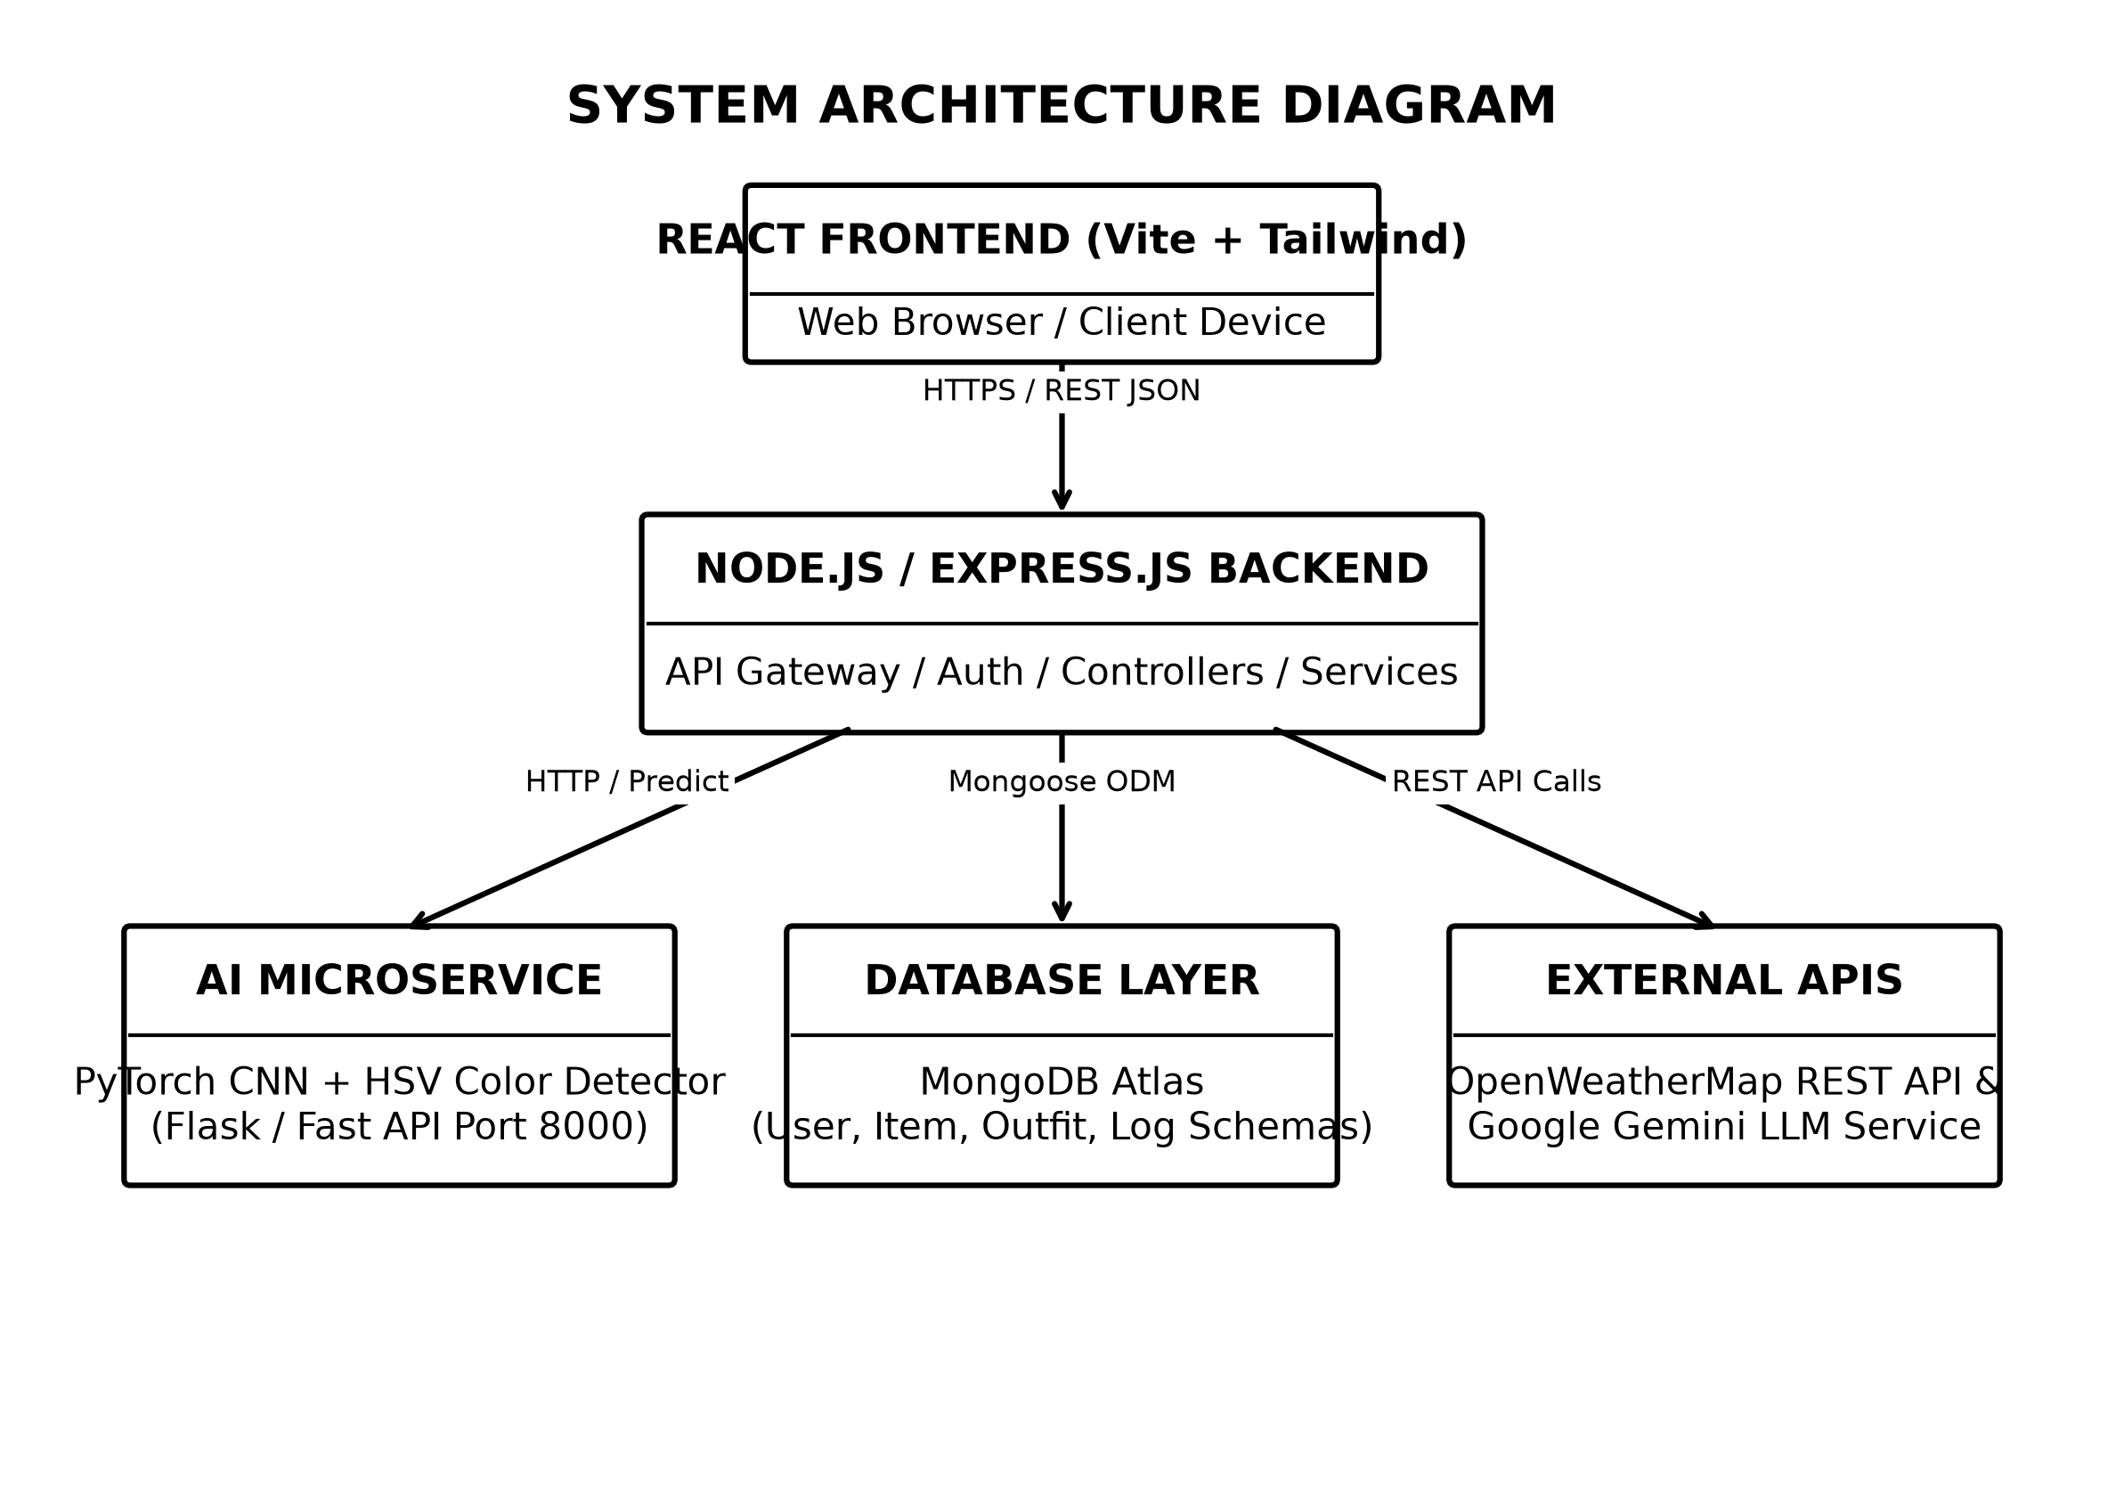
Fig. 5.1 System Architecture Diagram (Black & White)
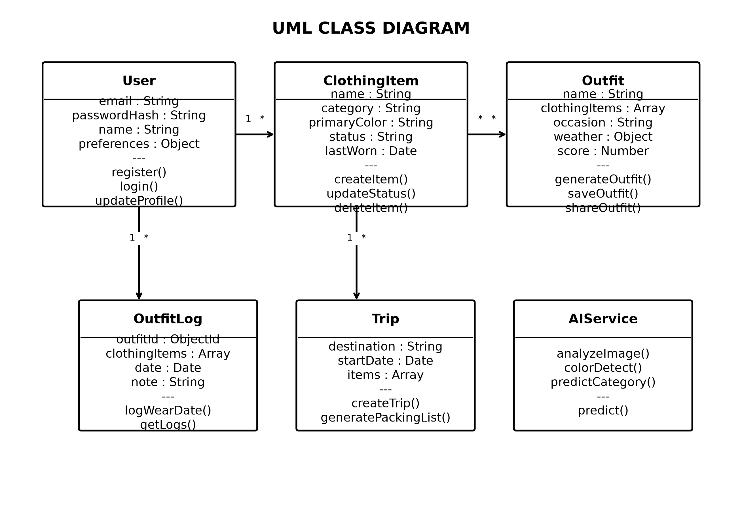
Fig. 5.2 UML Class Diagram (Black & White)
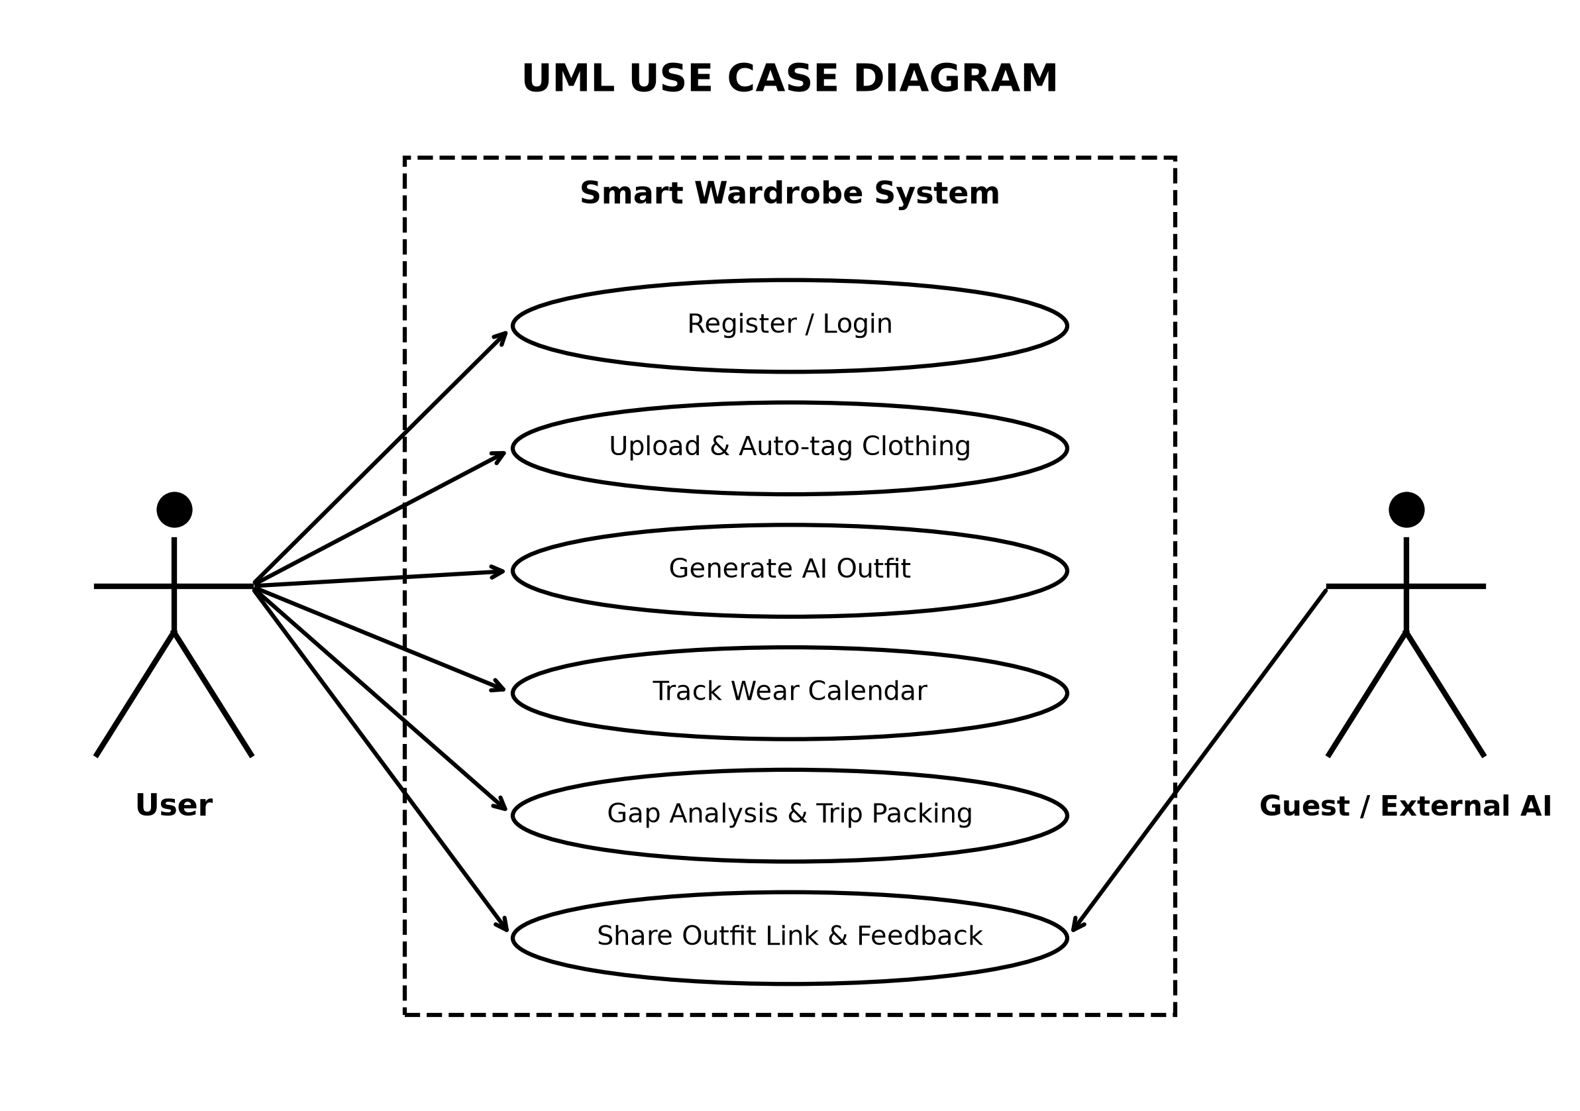
Fig. 5.3 UML Use Case Diagram (Black & White)
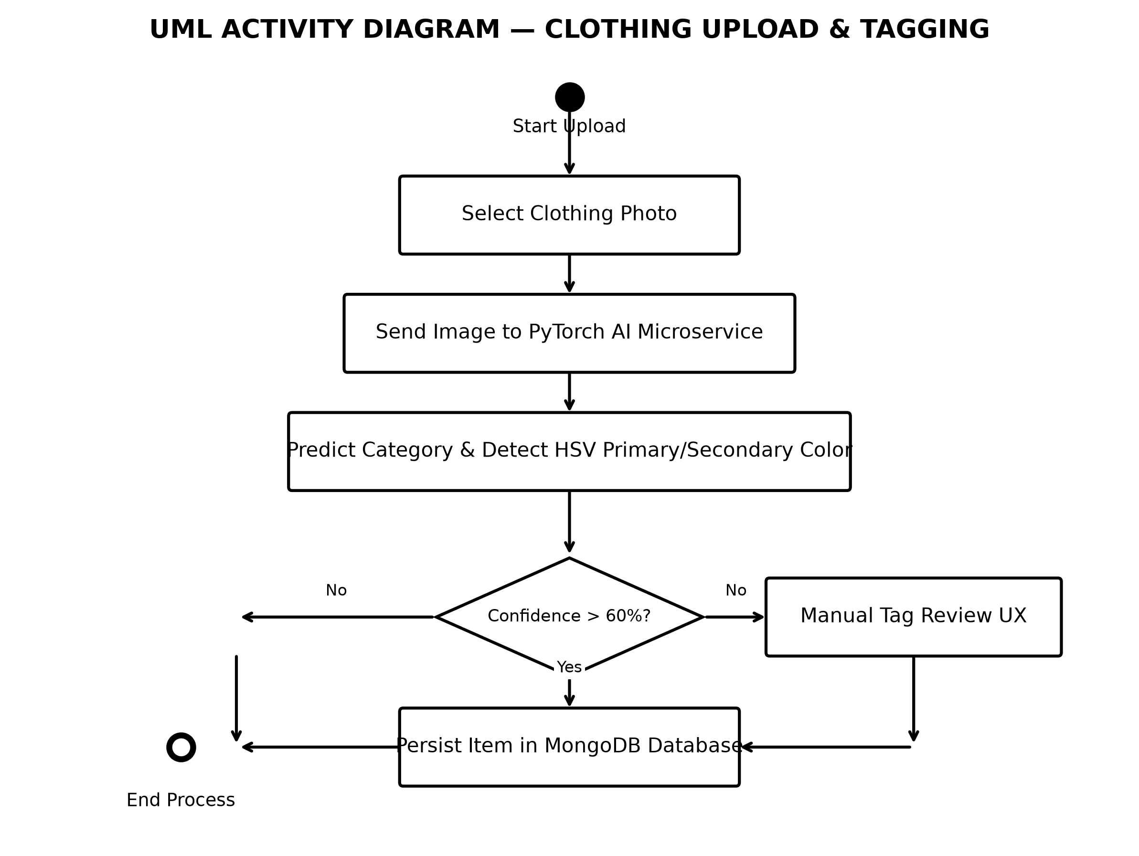
Fig. 5.4 UML Activity Diagram — Image Upload & Tagging (Black & White)
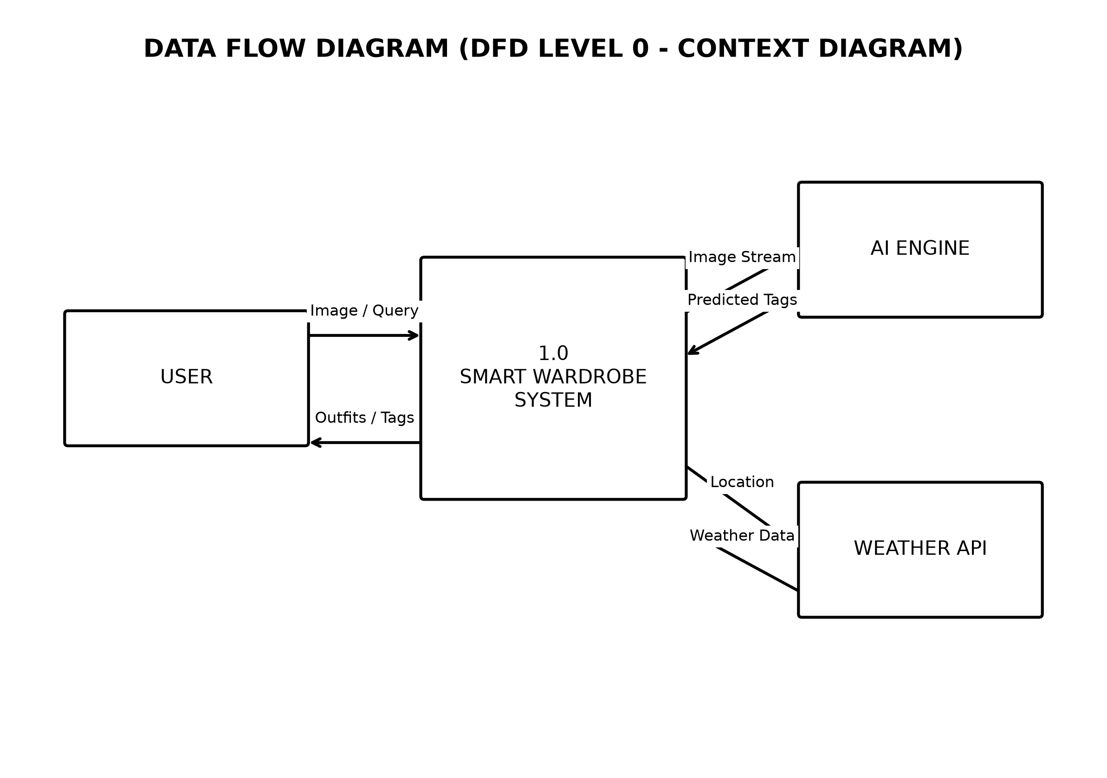
Fig. 5.5 Data Flow Diagram DFD Level 0 (Black & White)
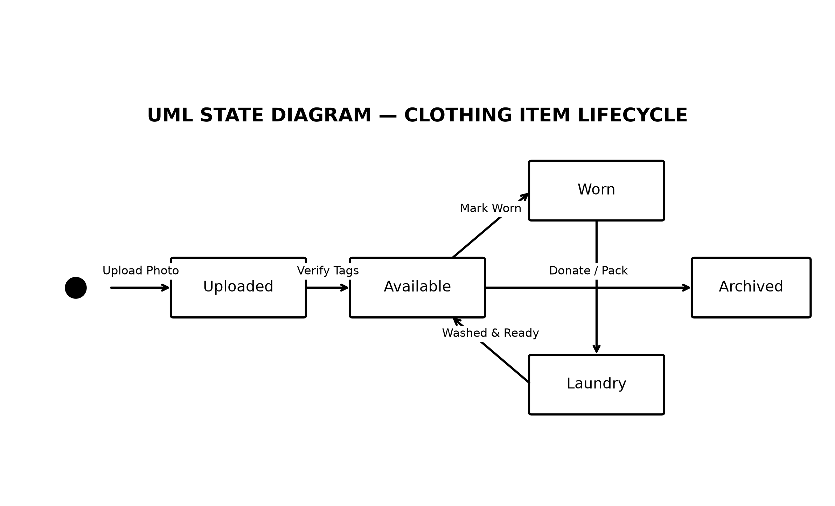
Fig. 5.6 UML State Diagram — Clothing Lifecycle (Black & White)
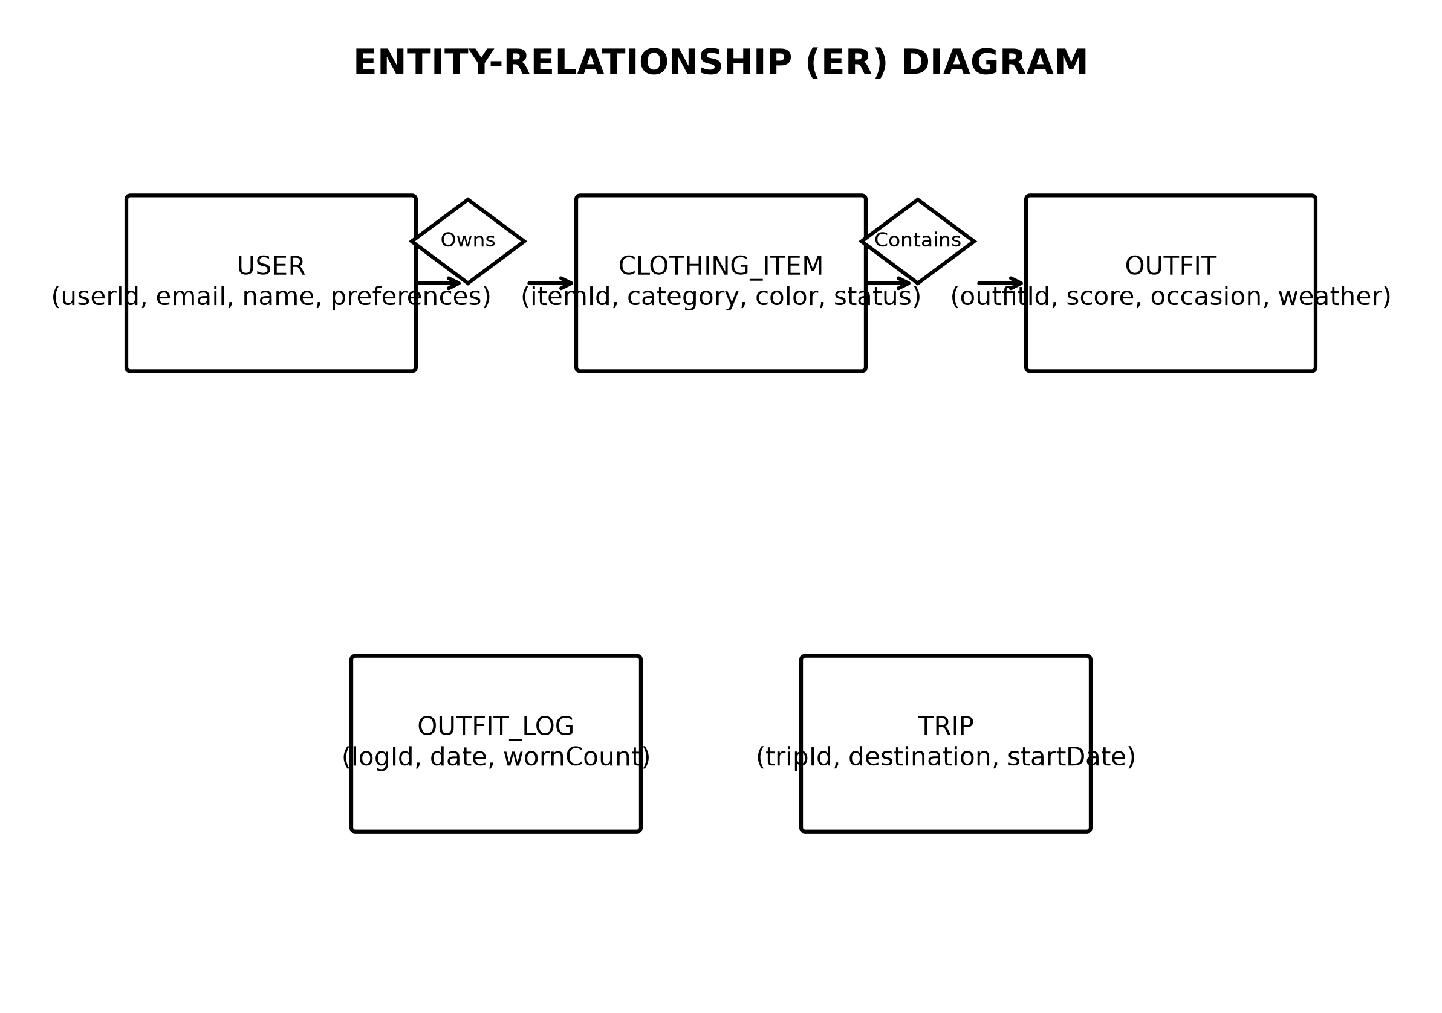
Fig. 5.7 Entity-Relationship (ER) Diagram (Black & White)
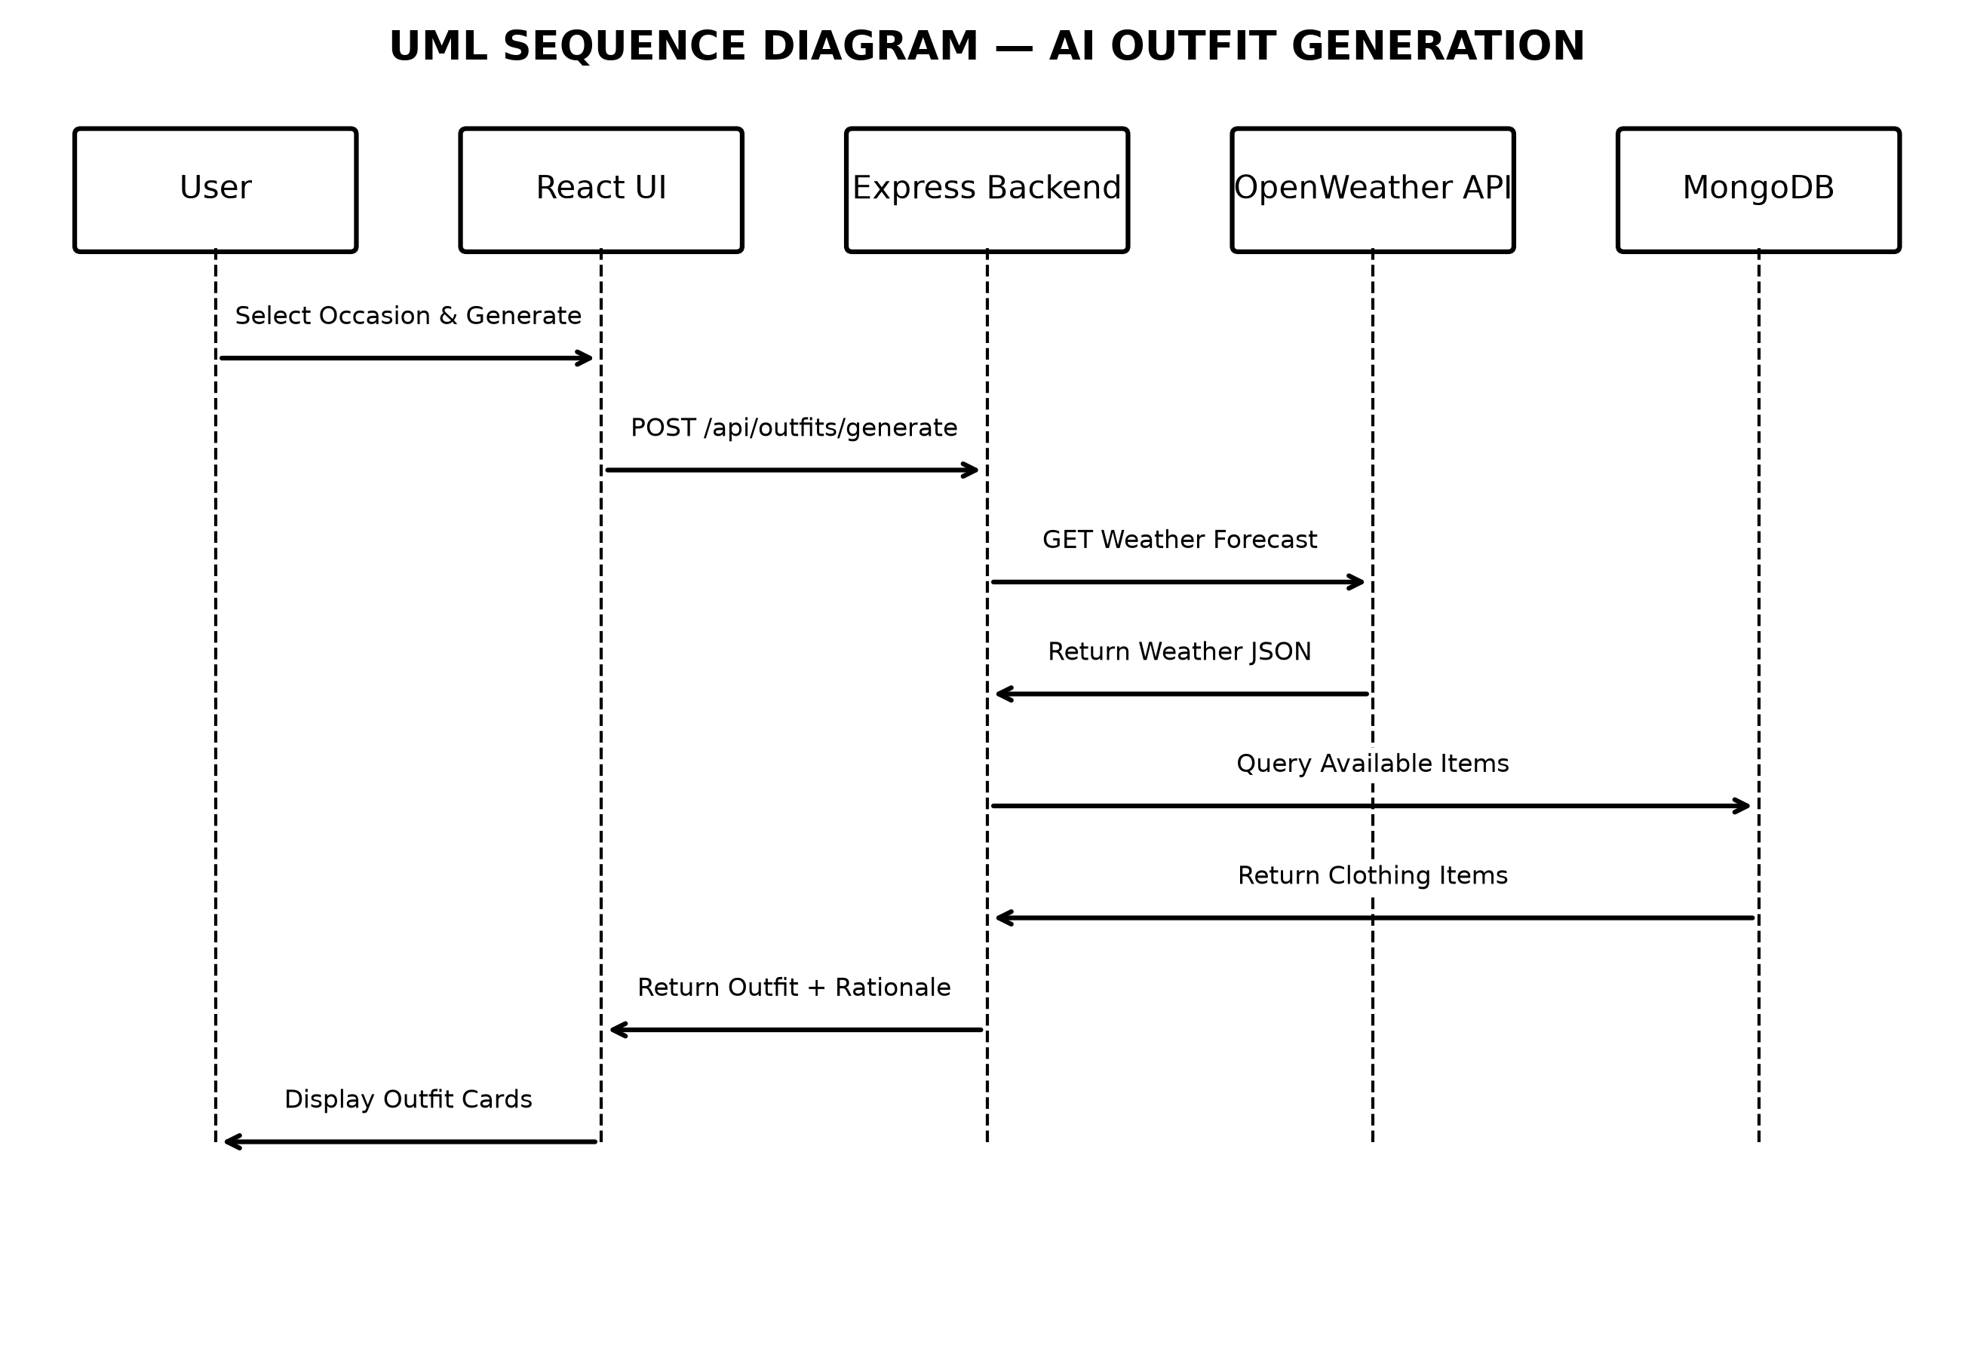
Fig. 5.8 UML Sequence Diagram — Outfit Generation (Black & White)
5.3 Screen Designs (Web Screenshots - Color)
Full-color screenshots demonstrating the responsive React web application user interfaces:
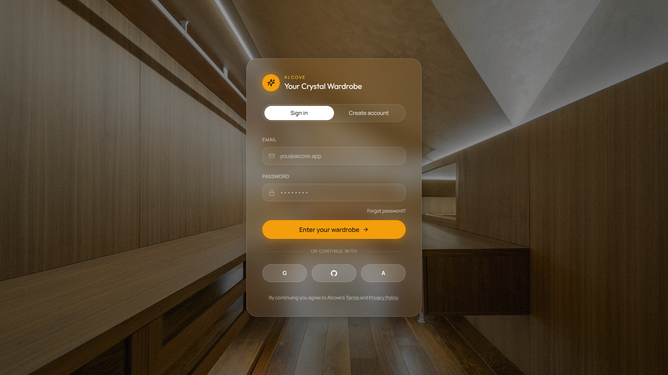
Fig. 5.9 Screen Design — User Authentication Interface (Color)
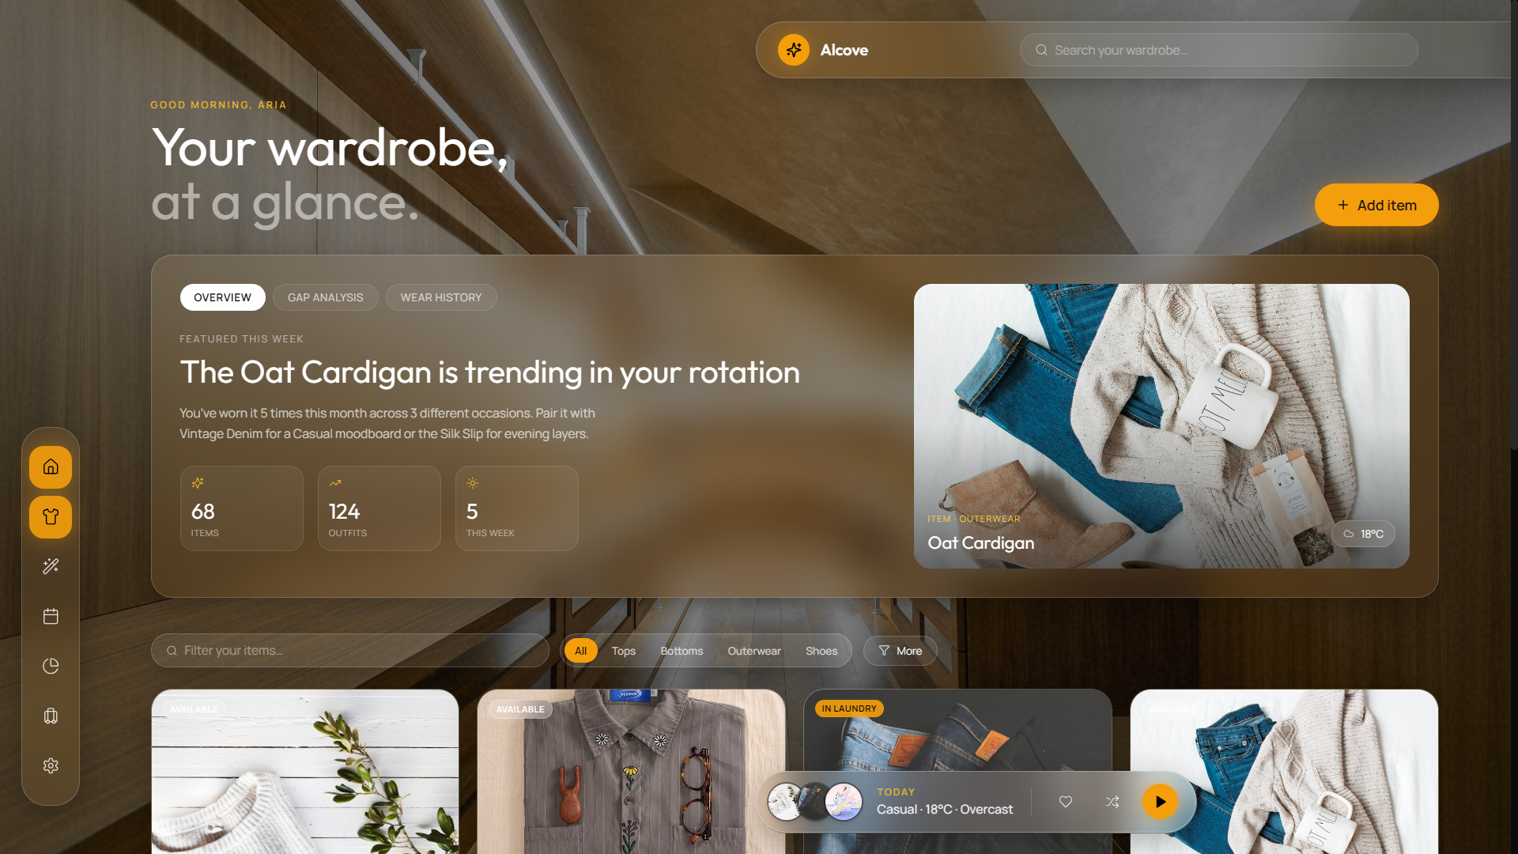
Fig. 5.10 Screen Design — Main Dashboard Overview (Color)
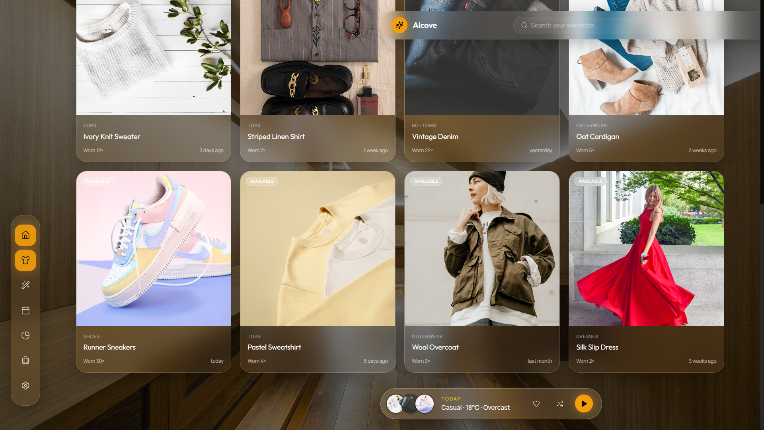
Fig. 5.11 Screen Design — Digital Wardrobe Catalog (Color)
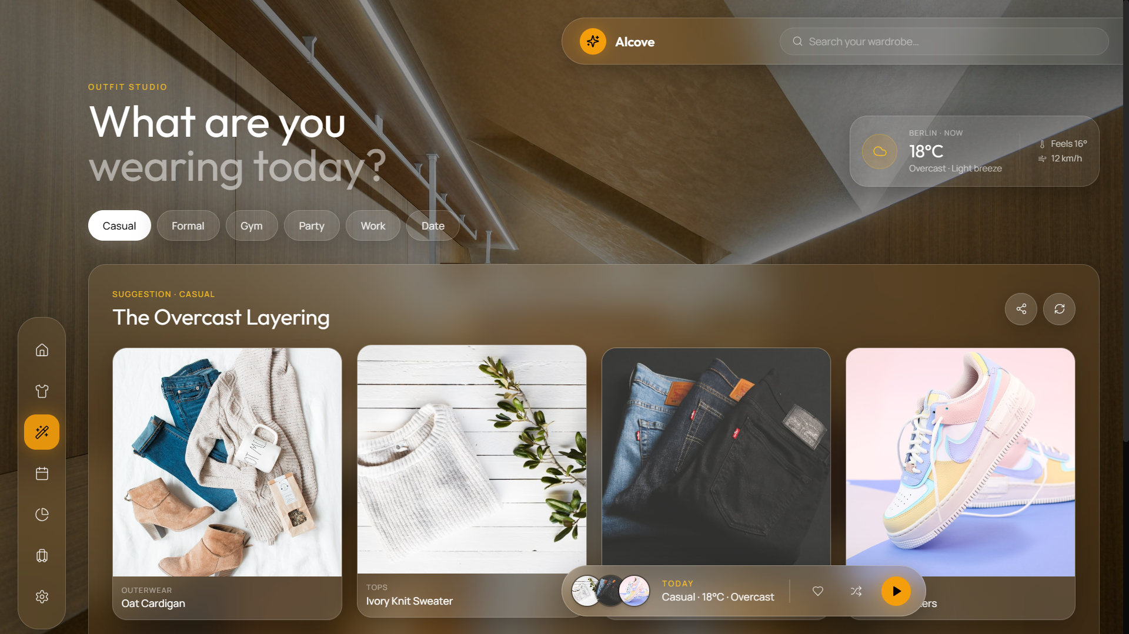
Fig. 5.12 Screen Design — AI Outfit Generator Interface (Color)
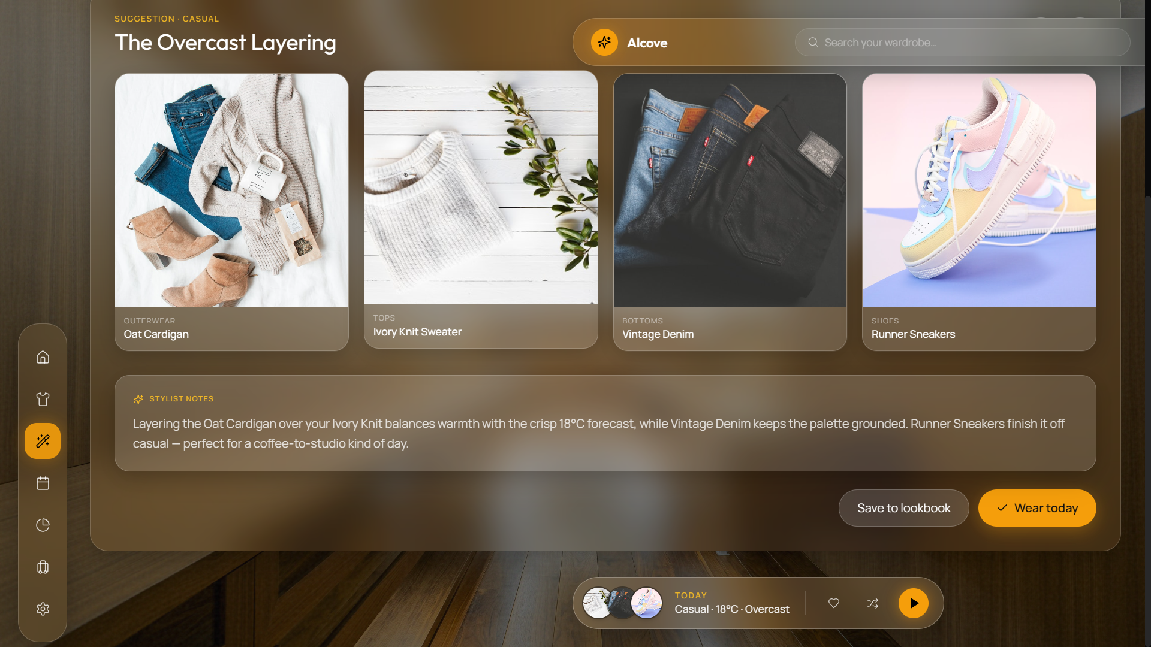
Fig. 5.13 Screen Design — Wear History Calendar Interface (Color)
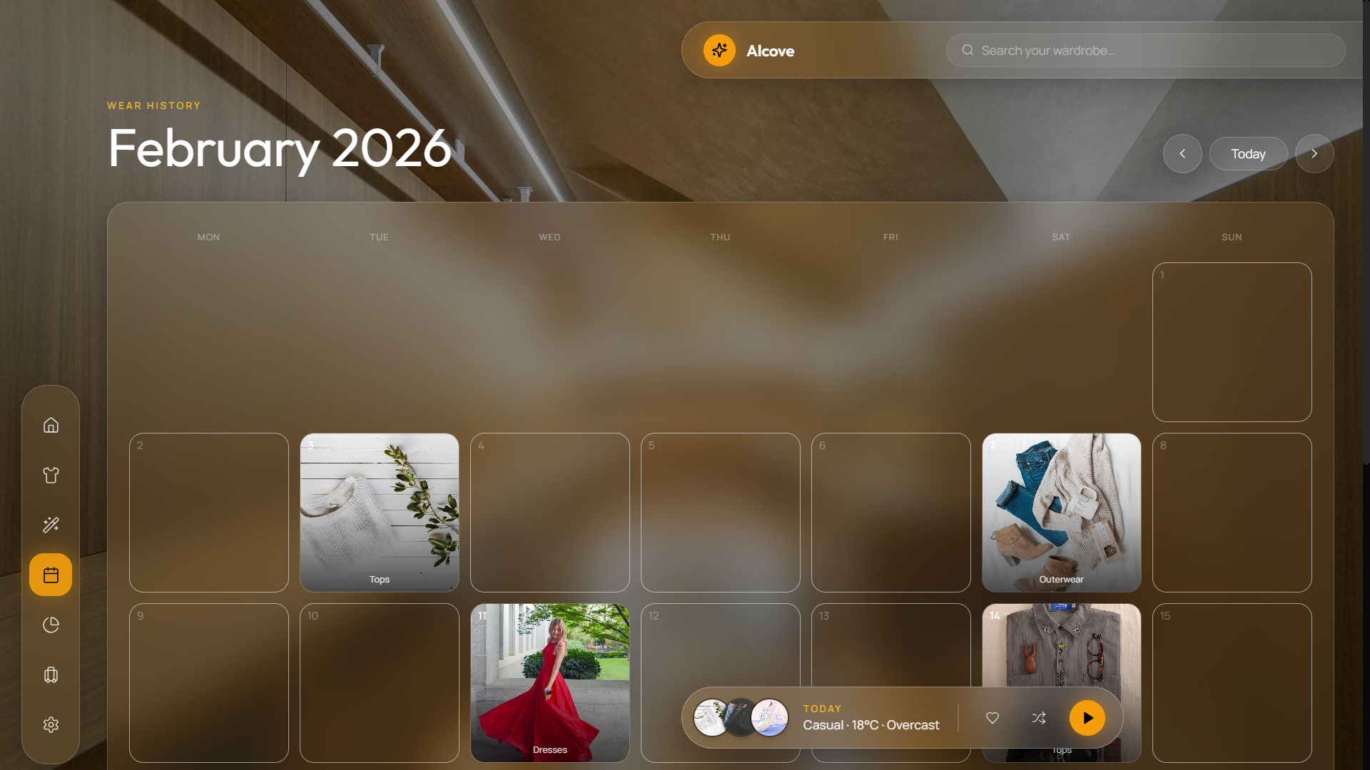
Fig. 5.14 Screen Design — Wardrobe Gap Analysis & Shopping Advice (Color)
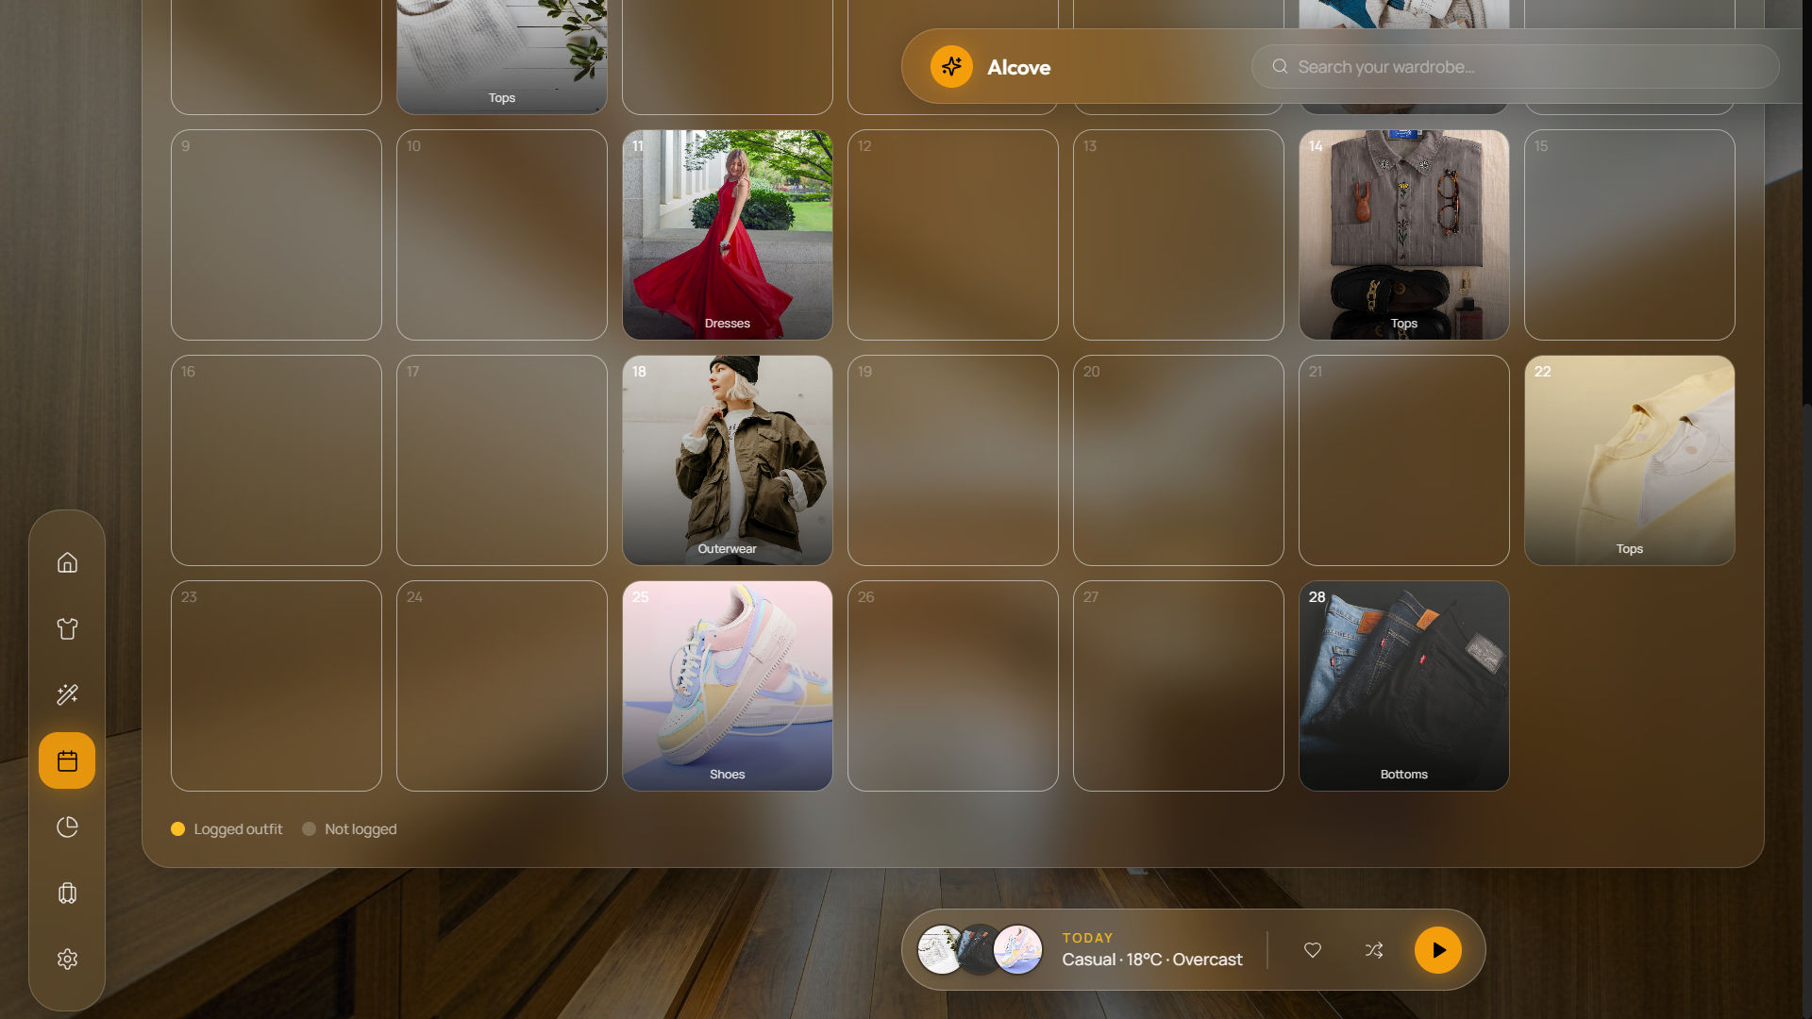
Fig. 5.15 Screen Design — Trip Packing List Generator (Color)
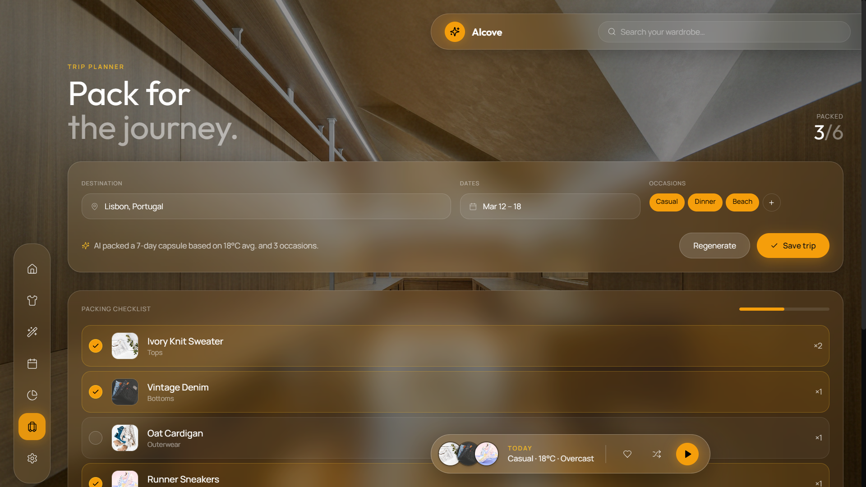
Fig. 5.16 Screen Design — Outfit Sharing Interface (Color)
CHAPTER – 6
CODE IMPLEMENTATION
6.1 Implementation Environment
The application implementation environment consists of:
• Node.js / Express Server listening on HTTP port 5000.
• React.js 18 SPA compiled via Vite 5 running on HTTP port 3000.
• Python 3.10 Flask AI microservice running on HTTP port 8000.
• MongoDB Atlas cloud database cluster connected via Mongoose ODM.
6.2 Program / Module Specification
Key backend and AI module implementations:
// backend/src/controllers/aiController.js (AI Analysis Handler)
async function analyzeClothing(req, res) {
if (!req.file) return res.status(400).json({ error: 'Image file required.' });
try {
const prediction = await analyzeImage(req.file.path);
return res.json({ prediction, needsReview: (prediction.category?.confidence || 0) < 0.60 });
} catch (aiError) {
return res.status(503).json({ error: 'AI microservice offline.', aiEngineDown: true });
}
}
# ai-engine/inference/predictor.py (PyTorch Classifier)
class ClothingPredictor:
def __init__(self, model_path, label_map_path):
self.model = torch.load(model_path, map_location='cpu')
self.model.eval()
def predict(self, image_path):
tensor = transform_image(image_path)
with torch.no_grad():
outputs = self.model(tensor)
prob, idx = torch.max(outputs, 1)
return {"category": self.labels[idx.item()], "confidence": float(prob.item())}
6.3 Coding Standards
• ES6+ Modular JavaScript syntax with strict async/await error handling.
• Python PEP8 compliance for AI engine scripts.
• RESTful API route naming conventions (/api/wardrobe, /api/outfits).
• Structured logging via Winston for database and server operations.
CHAPTER – 7
TESTING
7.1 Testing Strategy
A multi-tier testing strategy was applied combining unit testing, integration testing, validation testing, and AI model accuracy evaluations.
7.2 Testing Method
7.2.1 Unit Testing
Unit tests evaluated REST API controllers, authentication token verification, and utility functions using Jest and Supertest.
7.2.2 Integration Testing
Integration tests verified end-to-end data flows across React UI -> Express Server -> Python AI Microservice -> MongoDB database.
7.2.3 Validation Testing
Validation testing ensured input sanitization, file MIME type restrictions (JPEG/PNG/WEBP), and authorization checks.
7.3 Test Cases (Black & White Matrix)
Table 7.1 outlines the comprehensive test suite executed across system modules:
Test ID | Module | Test Scenario | Input Payload | Expected Result | Status
TC-01 | Auth | User Registration | Valid name, email, password | HTTP 201 + JWT Token issued | PASS
TC-02 | Auth | Duplicate Email | Existing registered email | HTTP 400 'User already exists' | PASS
TC-03 | Auth | Invalid Login | Incorrect password | HTTP 401 'Invalid credentials' | PASS
TC-04 | Wardrobe | Protected Route | GET /api/wardrobe (no token) | HTTP 401 'Authentication required' | PASS
TC-05 | Wardrobe | Image Upload | Valid JPEG clothing image | HTTP 200 + AI predicted tags | PASS
TC-06 | Wardrobe | Status Update | PUT status='laundry' | Item status updated to 'laundry' | PASS
TC-07 | AI Engine | Service Disconnection | POST image (Flask offline) | HTTP 503 + aiEngineDown=true | PASS
TC-08 | Outfit | Outfit Generation | Occasion='casual', temp=22°C | Valid top + bottom pair returned | PASS
TC-09 | Calendar | Log Wear History | Outfit ID + Date payload | Wear log created + wornCount++ | PASS
TC-10 | Trip | Generate Packing | Destination='Mumbai', 3 days | Minimal packing checklist output | PASS

CHAPTER – 8
LIMITATIONS AND FUTURE ENHANCEMENT
8.1 Limitations
• Color Extraction Sensitivity: HSV color detector accuracy depends on camera lighting and background clutter.
• Manual Image Upload: Garments must be manually photographed by the user.
• API Rate Limits: Free-tier LLM API endpoints impose request volume limits.
8.2 Future Enhancement
• Cross-Platform Mobile App: Native mobile app built with React Native for instant camera captures.
• AR Virtual Fitting Room: Augmented Reality overlay allowing users to preview outfits virtually.
• Smart Laundry Sync: NFC/RFID tag integration to track garment washing cycles automatically.
CHAPTER – 9
CONCLUSION
The Smart Wardrobe & Outfit Planner (Alcove) successfully demonstrates a modern, AI-integrated solution for digital wardrobe management and context-aware outfit recommendations. By combining the MERN stack with a Python deep learning microservice, the project effectively automates apparel cataloging, reduces daily decision fatigue, promotes clothing utilization, and supplies personalized styling advice. The implementation satisfied all functional requirements, security standards, performance metrics, and academic criteria.
CHAPTER – 10
REFERENCES
• 1. Liu, Z., Luo, P., Qiu, S., Wang, X., & Tang, X. (2016). DeepFashion: Powering Robust Clothes Recognition and Retrieval with Rich Annotations. IEEE CVPR.
• 2. He, K., Zhang, X., Ren, S., & Sun, J. (2016). Deep Residual Learning for Image Recognition. IEEE CVPR.
• 3. React Documentation. Facebook / Meta Open Source. https://react.dev/
• 4. Node.js & Express API Documentation. OpenJS Foundation. https://expressjs.com/
• 5. PyTorch Deep Learning Platform. Linux Foundation. https://pytorch.org/
• 6. MongoDB Manual & ODM Reference. MongoDB Inc. https://www.mongodb.com/docs/
• 7. OpenWeatherMap REST API Specification. OpenWeather Ltd. https://openweathermap.org/api
• 8. Google Gemini API & Generative AI SDK Documentation. Google DeepMind. https://ai.google.dev/

